- Introduction

This report on Responsible Investment (RI) is a companion to the LPPI RI Dashboard and the Quarterly Active Ownership Report (available from the online Pensions Library). It covers stewardship in the period 1 January to 31 March 2021 plus insights on current and emerging issues for client pension funds.

R This symbol indicates a term explained in the reference section at the end of this report.

Key takeaways for the period:

- LPPI has submitted annual reporting (as a signatory to the Principles for Responsible Investment) for the period 1st January to 31 December 2020.
- RI priorities identified by LPPI for the year ahead place focus on transparency, systematic ESG integration, social factors, and climate change sustainability.
- Investments in brown sectors (extraction, transportation, storage, supply, and generation of energy from fossil fuels) are 2.85% of the portfolio.
- Investments in green sectors (renewable energy generation, clean technology, and decarbonising activities) are 3.40% of the portfolio.
- LPPI has joined other investors in supporting a clear set of expectations for how banks should demonstrate alignment with the goals of the Paris Agreement.
- An-internet based letter campaign is underway by the Palestine Solidarity Campaign specifically targeting the LGPS

- RI Dashboard – portfolio characteristics

This section of the report shares key takeaways from the RI Dashboard at Appendix B.

Asset class metrics (Dashboard pages 1 & 2) offer insights on the composition of the portfolio and its general characteristics. There have been minimal changes compared with the position reported at Q4 2020.

Listed equities (Dashboard p1)

Sector Breakdown
Categorised by GICSR the largest sectoral exposures for the GEF are information technology (23%) consumer staples (13%) and industrials (13%).

Comparing the GEF with its benchmark (MSCI ACWI) R gives insight into how sector exposures for the fund differ from a global market index. The length of each horizontal bar indicates by how much exposures differ in total (+ or –) compared with the benchmark, which is the outcome of active managers making stock selection decisions rather than passively buying an index.

The GEF continues to be underweight conventional energy (GEF 0.6% versus 3.3% for MSCI ACWI) indicating a much lower exposure to companies extracting, transporting, storing, and supplying fossil fuels. This is in line with the Fund’s stance on climate change.

Top 10 Positions
The top 10 companies (10 largest positions) make up 23.5% of the total LPPI GEF.
There has been no change in ranking since last quarter for the top 7 companies; Estee Lauder has moved to 8th, Autozone has entered the list at 9th, and SPDR Gold Shares have remained 10th with Apple displaced from the list.

Portfolio ESG Score
The GEF’s Portfolio ESG score has risen from 5.1 (Q4) to 5.2 (Q1). In the same period the equivalent score for the benchmark increased from 4.9 (Q4) to 5.0 (Q1).

Transition Pathway Initiative (TPI)
Monitoring against TPI R Management Quality ratings confirms the GEF continues its relatively low exposure to highly carbon intensive activities. By value, only 13% of the GEF is in the globally high emitting companies under TPI assessment (unchanged from Q4). This is despite TPI rating coverage expanding by 44 additional companies in Q1.

The number of GEF companies in scope of TPI scoring has decreased by 8 (Q4 36, Q1 24). This reflects the expansion of the TPI universe (44 new companies brought within rating) and a change in the portfolio (liquidation of an external manager mandate which involved positions being sold).

Of the 24 companies in TPI scope:
- 91% (by value) are rated TPI 3 and above – demonstrably integrating climate change into their operational planning (TPI3) and into their strategic planning (TPI 4). This is down from 95% in Q4 and mainly reflects one new holding rated poorly by TPI.
- 7 companies are scored below TPI 3 and under monitoring.
- no extractive fossil fuel companies score below TPI 3 (100% compliance with LPPI’s target for this sector).

Other asset classes (Dashboard p2)

Private Equity
Sector and geographical exposures are largely unchanged from Q4. The portfolio has a strong US presence (43%) and largest sector exposure is to Information Technology (34%).

Infrastructure
Sector and geographical exposures are largely unchanged from Q4. The portfolio is predominantly focussed within the UK/Europe (43% / 37%) and is 61% utilities (supply of power and water).

Through a new investment by GLIL Infrastructure, the Fund will be helping to fund the development of the UK’s sustainable energy infrastructure via an investment in Smart Meter Assets. https://www.glil.co.uk/media/glil-infrastructure-and-arcus-acquire-smart-meter-assets
The Real-World Outcomes section of the dashboard features further examples of socially positive infrastructure investments. Pages 6-7 share information on the renewable energy generation Fund investments are helping to produce in the UK (sufficient to power more than 1 million homes) and feature investments in railway infrastructure directly supporting the railway transport industry in the UK and helping to create highly skilled jobs, ease transport congestion, and reduce emissions.

Real Estate
Sector and geographical exposures are unchanged from Q4.
The portfolio is 74% UK assets and has a 37% weighting to industrial uses (logistics).

Green & Brown Exposures
Calculation of the Fund’s exposure to Green and Brown activities focusses specifically on equity assets (listed equity, private equity, and infrastructure) plus green bonds within fixed income. Figures give an indication, rather than a precise measure, as an assistance to reviewing the overall position.

Green activities are those directly contributing to real world decarbonisation, principally through renewable energy generation, but include other activities supporting lower emissions including district heating, and waste management. Brown activities are those directly involved with extracting, transporting, storing, and otherwise supplying fossil fuels, or using them to generate energy.

For the first time, the dashboard presents information on the trend in green and brown exposures (commencing in Q4 2019). Quarterly changes in Green and Brown exposure reflect multiple factors at play including funds reaching maturity, assets being revalued, and investments being made and sold. The total value of the LCPF portfolio (as the denominator) also affects brown and green % shares quarterly.

Compared with Q4 2020, both brown and green exposures have changed.

Brown activities are 2.85% of the portfolio (Q4 2.99%). Noting a downward valuation for one infrastructure fund, the main cause of the reduction is a shift in LCPF’s proportionate ownership of the total LPPI Infrastructure pool relative to other investors. This reflects the effects of the phasing and timing of drawdowns and allocations within investment tranches. A smaller relative share of the total infrastructure pool (compared with Q4) translates to a lesser share of brown (and green) assets held by the pool.

Green activities are 3.4% of the portfolio at Q1 (Q4 3.84%). The reduction reflects the decreased ownership share of the LPPI infrastructure pool (as described above) but is more heavily reflective of the sale of a legacy bio-gas asset on LCPF’s behalf which was not part of the LPPI infrastructure Pool.

Investments in renewable energy generation from wind, solar, hydro, and waste make up 81% of total green exposure. LCPF’s green exposure is 98% via infrastructure investments.

Core Stewardship

This section of the report gives an overview of stewardship activities in the last quarter.
Client pension funds delegate day to day implementation of the Partnership’s approach to RI to Local Pensions Partnership Investments Ltd (LPPI). Ongoing stewardship activities by LPPI include portfolio and manager monitoring and the exercise of ownership responsibilities via shareholder voting, and engagement.

Shareholder Voting - LPPI Global Equity Fund (GEF) (Dashboard page 3)

Shareholder voting is overseen centrally by LPPI rather than by individual asset managers. LPPI receives analysis and recommendations from an external provider of proxy voting and governance research. We follow Sustainability Voting Guidelines focussed on material ESG considerations and liaise with providers and asset managers as needed to reach final voting decisions.

Full details of all shareholder voting by LPPI is publicly available from the LPP website within quarterly shareholder voting reports.

The period January to March 2021 encompassed 62 meetings and 603 proposals voted. LPPI voted at all meetings where GEF shares entitled participation.

- Company Proposals

LPPI supported 95% of company proposals in the period.
Opposition voting concentrated on
- the election of directors (addressing individual director issues, overall board independence, and over-boarding)
- non-salary compensation (addressing inadequate disclosure of underlying performance criteria, use of discretion, and the quantum of proposed rewards).

Insights – Director related

Diversity
At Canon, Inc (Japan: Technology Hardware, Storage & Peripherals) LPPI voted against the re-election of three representative directors.
At Korea Shipbuilding & Offshore Engineering Co (South Korea: Construction Machinery & Heavy Trucks) LPPI voted against an insider director.
At both companies voting reflected the absence of any female board members. (Results not disclosed).

Overboarding and Independence
At Fomento Economico Mexicano (Mexico: Soft Drinks), LPPI voted against the bundled slate of director nominations due to the presence of three overboarded directors, an insufficiently independent Board, and the practice of the bundled slate. (Result not disclosed)

At Max Financial Services Limited (India: Life & Health Insurance), LPPI voted against one director due to attendance being below 75% without a satisfactory explanation. Result: 10.0% against.

At Svenska Handelsbanken AB (Sweden: Diversified Banks), LPPI voted against the election of three director nominees on the grounds they would serve as non-independent directors on an Audit Committee with an already insufficient level of independence. (Results not disclosed)

Insights – Non-salary compensation

LPPI voted against six remuneration proposals across six companies.
LPPI voted against the say on pay at:
Starbucks (USA: Restaurants) where analysis highlighted the second consecutive use of a “one-time” pay award and insufficient rationale for a significant long-term performance award being paid entirely in cash. Result: 52.5% Against.

Becton, Dickinson and Company (USA: Health Care Equipment), opposing the use of one time pay awards to offset the lower value of long-term performance shares for NEOs. The company acknowledged the low award was not solely due to the pandemic and did not provide sufficient justification for the one-time award. Result: 33.0% Against.

Hologic, Inc (USA: Health Care Equipment) due to a lack of clarity in aspects of the Long-Term Incentive Plan, the lack of stretch in performance targets, and concerns around payments to a retiring NEO not yet eligible for them. Result: 31.0% Against.

Insights - Shareholder Proposals

LPPI voted on six shareholder proposals, supporting three (50%).

At Visa (USA: Data Processing & Outsourced Services) LPPI supported a resolution to provide shareholders the right to act by written consent (as a means to raise important matters outside the normal annual meeting cycle). Result: 40.8% For.

At Apple (USA: Technology Hardware, Storage & Peripherals), LPPI supported the proposal to expand the rights of shareholders to nominate Board members, setting this at the greater of 20% of the board or at least two candidates. Result: 34.2% For.

At Becton, Dickinson and Company (USA: Health Care Equipment), LPPI supported the proposal to reduce the ownership threshold for shareholders to call a special meeting from 25% to 15%. Result: 45.8% For.

Shareholder Engagement

Company and manager engagements are underway on an ongoing basis, directly through board seats and Limited Partner Advisory Committees (LPAC) for private market assets, and more conventionally through shareholder engagement with listed companies.

LPPI’s engagement partner Robeco has completed a fifth full quarter of engagement activity. The RI Dashboard (page 4) presents engagement headlines for the quarter which confirm the Robeco Active Ownership Team undertook 53 activities in total, and the predominant focus (by topic) was environmental management.

Page 5 of the Dashboard summarises the current status of each live engagement theme (as it stood at the end of Q1). Robeco have reformatted the summary of Results by Theme to show them grouped according to whether they are E,S or G themes.

21 themes were live at the end of Q4. Of these, 4 themes (Sound Environmental Management, Sound Social Management, Good Governance, and Global Controversy Engagement) are evergreen, the remaining 17 are thematic and reflect priorities identified through a combination of Robeco research and client input. Each theme is scheduled to last approximately three years, with progress continually tracked against clear objectives.

The Active Ownership Report (a copy of which is available for Committee members to view in the online Pensions Library) provides detailed narrative on thematic engagements underway with listed companies (representing shares held by the Global Equities Fund, or corporate bonds held by the LPPI Fixed Income Fund).

Each quarter, we provide further insights into one of the live themes underway by the Robeco Active Ownership Team.

Case study – Digital Innovation in Healthcare

Robeco commenced the Digital Innovation in Healthcare theme in 2019. At its launch, healthcare was considered under pressure. Demographic and socio-economic trends, in combination with competitive pressures such as increased regulation and pricing, were acting to erode healthy operating margins. Robeco believe digital innovation will not only protect margins through increased productivity, but result in better health outcomes at lower cost, contributing to Sustainable Development Goal 3 (good health and well-being).

One example is telehealth, an umbrella term referring to remote healthcare. By streamlining the health care system, patients with low-complexity issues can be treated outside of health care facilities, improving the capacity to treat patients with acute medical needs. Telehealth can also enhance access by reducing barriers to treatment, for example time or distance. Healthcare has been an industry traditionally slow to adopt technology for a number of complicated reasons. Due to the interconnected nature of treatment, collaboration is required between multiple stakeholders - governments, pharmaceuticals, healthcare providers, insurers, and patients - to make progress and gain benefits.

The main objective of the engagement is to explore how digitalisation of the health care sector can reduce pressure on health care. The companies under engagement for LPPI are HCA Healthcare Inc and Anthem Inc.

The engagement is focussed on the foundations and capabilities for digital innovation as a route to adoptable solutions.
The areas of focus are:
- Digital strategy: encouraging digital expertise across all levels of the organisation (including the Board) to unlock opportunities from data.
- Sectoral collaboration: generation of data standards which can be used to collaborate and innovate across firms, while remaining cautious and responsive to patient privacy concerns.
- Innovation management: pushing for the successful use and integration of new digital technologies within R&D.
- Sales and marketing innovation: modernising sales and marketing to save costs and the enhancing of pricing discipline through reliable data.
- Cybersecurity: improving risk management for all actors in the health care sector, reflecting patient trust is critical to the success of digital strategies.

Progress so far for LPPI’s companies under engagement is neutral to positive.
At HCA, Robeco held a conference call with the CFO which produced a positive view of the firm’s digital strategy, noting board oversight of cybersecurity and significant investment in it, plus successful efforts to streamline workflows through tech, and explore partnerships with tech companies to further innovation.

At Anthem, Robeco has gained comfort around the approach to cybersecurity (following improvements driven by reflections on a 2015 hack) and learnt more about the digital strategy, including targets to eliminate paper applications and invest in capacity to insource data functions to improve quality. As this theme enters its second half, Robeco note an expectation of further positive outcomes as trust is built in the dialogue between parties involved.

- Collaborations and Partnerships

LPPI participates in a range of investor groups and partnerships which provide opportunities for shared learning and a platform for collective action. The following are headlines for 2021 Q1.

Investor Expectations of Banks

LPPI has joined other investors (co-ordinated by the IIGCC R ) in publicly supporting a clear set of investor expectations for how the banking sector should demonstrate alignment with the goals of the Paris Agreement.

The expectations address the position of the banking sector as a funding provider and encourage the sector to steadily eliminate financing of fossil fuel and other misaligned activities inconsistent with a 2050 emissions target of net zero, while increasing finance to zero and low-carbon solutions which will assist its achievement.

Workforce Disclosure Initiative (WDI)

LPPI is a member of the Workforce Disclosure Initiative. Our subscription (and participation) support the development of more transparent reporting by listed companies and facilitate engagement on workforce related issues as part of our stewardship (the consideration of material social and governance matters).

WDI are currently gearing up for the 2021/22 cycle of company engagements and LPPI will be seeking to participate, by engaging with companies held within the internally managed global equities portfolio which are not yet disclosing and asking them to consider completion and submission of the detailed annual questionnaire.

LGPS Scheme Advisory Board (SAB) – RI Advisory Group (RIAG)

A new webpage has been launched which records the work of the new SAB RIAG
LGPS Scheme Advisory Board - RIAG Meetings (lgpsboard.org)

The group is chaired by Sandra Stewart (Greater Manchester Pension Fund) and assembles a wide cohort of members with secretariat by the Local Government Association. https://lgpsboard.org/index.php/riag-membership LPPI’s Head of RI is one of three Pool representatives.

The RIAG’s initial meeting (3rd March 2021) agreed terms of reference and began the review of an online RI Database which group members will help to maintain and develop. The database is now live on-line and offers an accessible A to Z guide or “one stop shop” of Responsible Investment information. The new resource is open access and will develop over time as an assistance to LGPS pension fund members and stakeholders. It is designed to demystify the hundreds of terms (and many acronyms) that routinely crop up as part of RI and to support pension fund committee and local pension board members in their duties.

Client funds are encouraged to take a look at the A to Z and to provide feedback on any matters they feel could usefully be added, something which can be quickly and easily done using the “what’s missing” link.

An image of the front page is shown below, which demonstrates that the A to Z has search and filter facilities, assistance on how to use the site, and a space for case studies that Pension Schemes are encouraged to contribute.

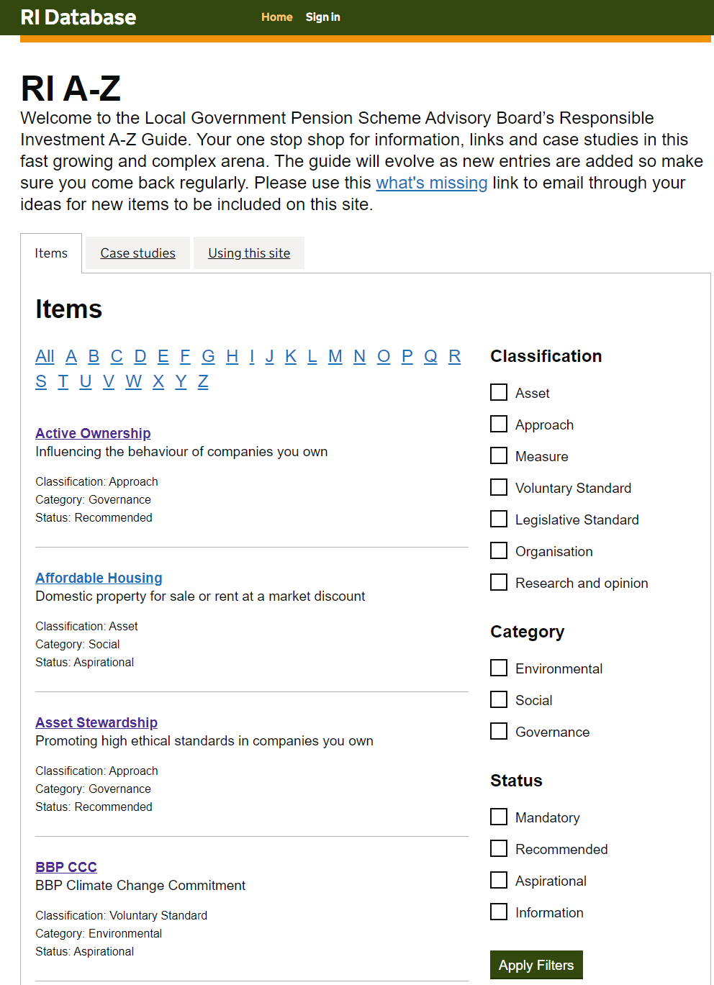

The RIAG’s second meeting (14th April 2021) was attended by MHCLG and confirmed a consultation paper is under development on compulsory reporting in line with recommendations by the Taskforce on Climate related Disclosure (TCFD). TCFD proposals for LGPS pension funds are expected to mirror the DWP requirements for Trust based Pension schemes which have already been published, with requirements likely to commence in 2022 with first reporting for financial year 2022/23.

LPPI will provide further information to client pension funds once the consultation paper has been issued.

- Other News and Insights

Principles for Responsible Investment (PRI)

LPPI submitted detailed annual reporting for the period 1st January to 31 December 2020 at the end of April.

Signatories to the Principles for Responsible Investment are required to report annually under a lengthy and time-consuming disclosure process. In 2021 reporting has been made harder by an updated online reporting platform supporting a revised and extended PRI questionnaire. Implementation encountered a number of issues and delays which required the online platform to remain open until mid-May.

No firm date has been given for the release of 2021 scoring which has also been revised this year and will mean prior year ratings are not directly comparable with results of the new assessment approach introduced for 2021.

LPPI RI Priorities for the year ahead

LPPI introduced the RI issues identified as priorities for the year ahead to representatives from client pension funds who attended the Client Forum held on 21 April 2021.

Prioritisation has encompassed a range of influences which shape what is required of LPPI as an asset manager. These include what evolving standards and regulations set as best practice, the themes and issues arising from the assets we are managing, and the responsibilities and interests of our clients as Administering Authorities.

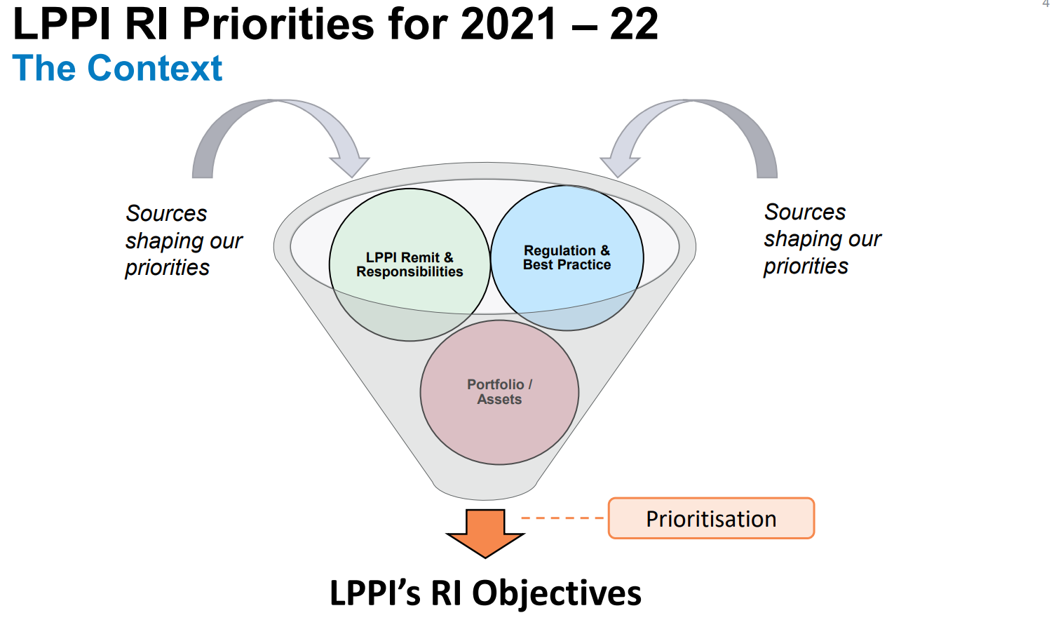

The priorities we have identified span our stewardship activities and our reporting on them, our investment practices, our RI Policy, and portfolio sustainability.

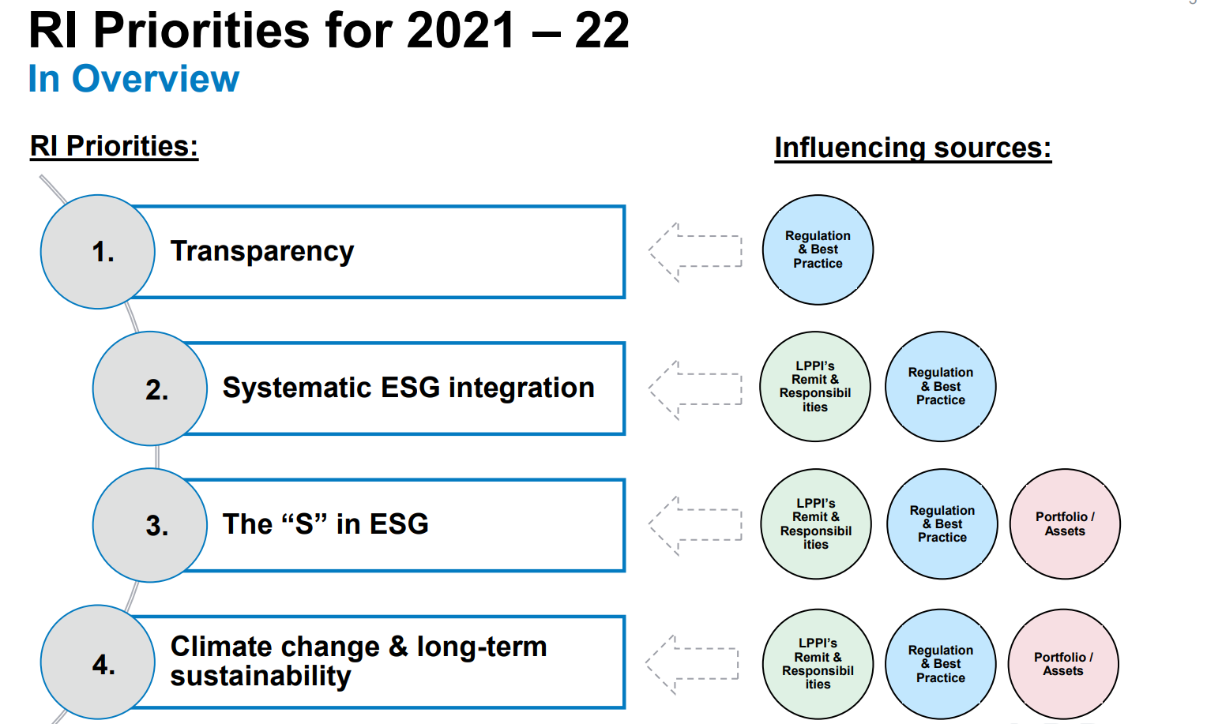

The emphasis on transparency reflects that we aim to continue current efforts to improve reporting to clients on our stewardship of their assets and to expand our disclosure to wider stakeholders through the information we share within public reporting.

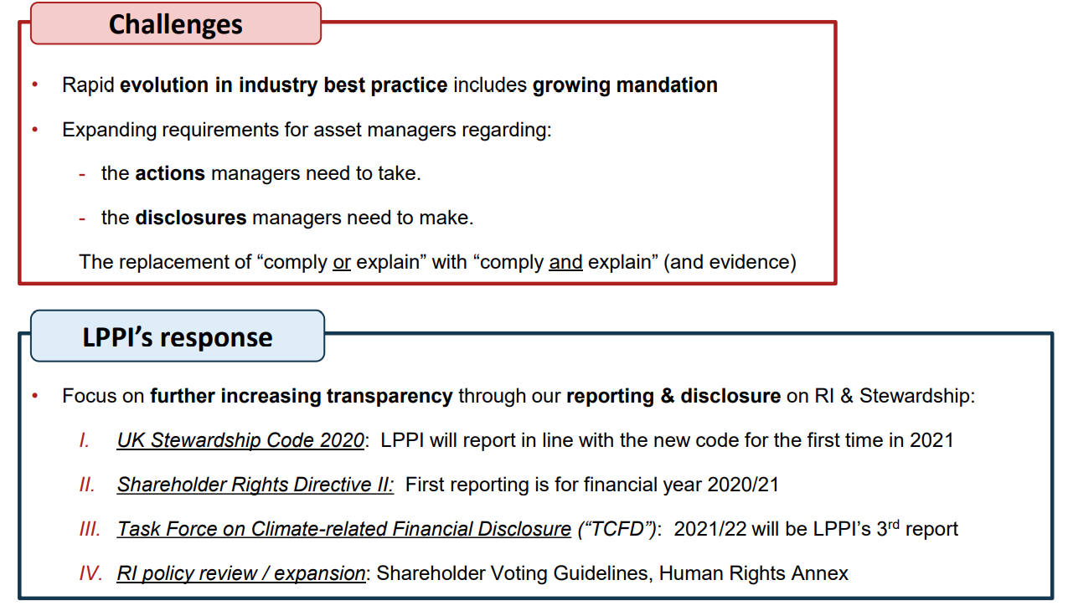

The focus on systematic ESG integration reflects our continuing effort to ensure our core investment processes embed the evaluation and monitoring of Manager ESG competencies and understand the ESG risks and opportunities the portfolio encompasses.

A focus on the S in ESG recognises the dominance climate change has had an investor priority and the relative subordination of social issues by comparison. This is an imbalance COVID 19 has shown us requires redress. The pandemic has demonstrated connectivity between the global economy, the welfare of society and the natural environment’s capacity to sustain both and has brought a stronger spotlight to a range of existing issues including diversity and inclusion, in work poverty, inequality of opportunity and pay, and respect for human rights. Our focus on S will include developing an annex to LPPI’s RI Policy related to Human Rights responsibilities in an investment context.

Climate change and portfolio sustainability relate to deciding LPPI’s stance (as an asset manager) on the Net Zero by 2050 agenda. Considerable work is envisaged as part of scoping and delivering an approach to sustainable investment which addresses the implications (for investors) of a growing momentum to achieve an environmentally sustainable global economic model through just and ordered transition away from fossil fuel dependency within a very constrained time period.

Pension Fund Trustees and Consideration of Social Risks

In March, the DWP R launched a 12-week Call for Evidence seeking views on how well pension scheme trustees understand social factors and how these considerations are reflected in Environmental, Social, and Governance (ESG) policies.

The call reflects that social factors can present a wide range of potential risks to pension scheme investments but can also produce investment opportunities. The DWP questions the effectiveness of occupational pension scheme trustees’ current policies and practices in relation to social factors and asks for more information as part of deciding whether measures to improve standards are necessary.
Responses are being invited to “help inform Government on steps needed to ensure trustees are able to meet their legal ESG obligations”.
Whilst the Call for Evidence relates specifically to trust-based pension schemes there is a strong likelihood any recommendations arising as a result of the review will be considered equally applicable to Administering Authorities for LGPS schemes.
The Call for Evidence period runs from 24 March 2021 and concludes 16 June 2021. LPPI will be making a response on behalf of the Partnership from an LGPS perspective.

LGPS Divest

An-internet based letter campaign specifically targeting the LGPS is underway by the Palestine Solidarity Campaign (PSC). The LGPS Divest campaign enables interested parties to input their postcode and customise a standard letter which is automatically emailed to their local councillor.

Letters call on local councillors to use their influence to divest LGPS pension funds of investments in companies which provide products, equipment, and services described as “essential to Israel maintaining its grave violations of Palestinian rights”.

PSC are the campaign group which successfully challenged the Government’s guidance to LGPS funds that they “Should not pursue [ESG] policies that are contrary to UK foreign policy or UK defence policy”.

LPPI has produced a client briefing paper providing further information on the campaign and the issues it raises to support pension funds who are considering their position preparatory to making a response to any letters they have received.

For Reference

GICS - Global Industry Classification System
The most widely used approach to categorising activities into industry sectors. The main standard in use for public markets with growing use for other asset classes.
For more information on GICS and the activities that fall into each sector see:
https://www.spglobal.com/marketintelligence/en/documents/112727-gics-mapbook_2018_v3_letter_digitalspreads.pdf

IIGCC – Institutional Investor Group on Climate Change. LPPI is a member.

MSCI ACWI - MSCI All Country World Index
A stock index designed to track broad global equity-market performance.
The LPPI Global Equity Fund’s benchmark.

MSCI - Morgan Stanley Capital International A global index provider.

MHCLG - Ministry of Housing, Communities and Local Government

PRI – Principles for Responsible Investment

TCFD - Taskforce on Climate Related Financial Disclosure
The Financial Stability Board created the Task Force on Climate-related Financial Disclosure (TCFD) to improve and increase reporting of climate-related financial information by companies and investors.
Recommendations include annual disclosure under 4 pillars:

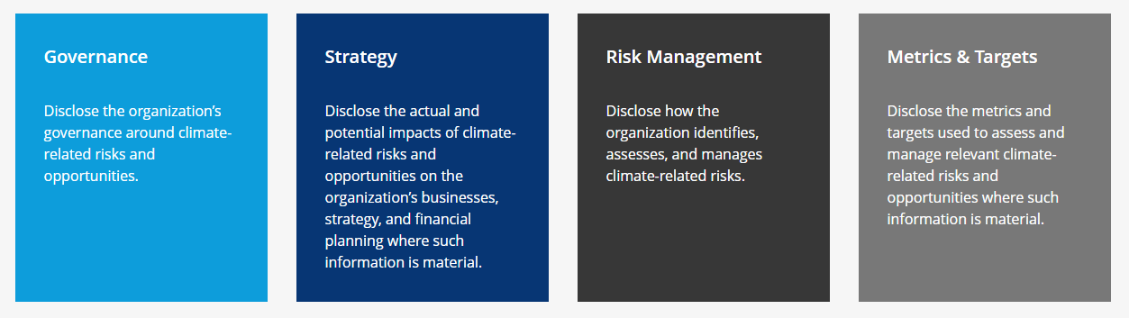

TPI - Transition Pathway Initiative https://www.transitionpathwayinitiative.org/
The TPI assesses highest emitting companies globally on their preparedness for transition to a low carbon economy.
368 companies are rated TPI 0-4* for Management Quality based on 19 separate datapoints. TPI Management Quality scores provide an objective external measure of corporate transition readiness.

